VGSOT-MTJ

首页

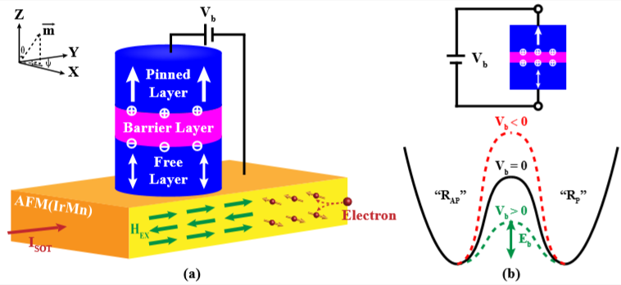

Introduction

This model file introduces a compact model of a voltage-gated spin-orbit torque magnetic tunnel junction (VGSOT-MTJ), where one MTJ with perpendicular magnetic anisotropy (PMA) is fabricated on an antiferromagnetic-metal (AFM) stripe. This model integrates the physical models for both the static and dynamic switching behavior. To exactly describe the magnetization switching of the VGSOT-MTJ, the following effects are taken into account in this model: (1) Voltage-Controlled Magnetic Anisotropy (VCMA) effect induced by the bias voltage across the MTJ; (2) damping- and field-like Spin-Orbit-Torque (SOT) effect induced by the charge current flowing through the AFM stripe; (3) damping- and field-like Spin Transfer Torque (STT) effect induced by the charge current flowing through the MTJ. Additionally, both the dependence of the TMR ratio on the bias voltage and the relationship between the MTJ resistance and the magnetization polar angle are also considered in this model. It provides an easy way to simulate the non-volatile memory and logic circuits based on the VGSOT-MTJ device.

Keywords: Compact model, Voltage-Controlled Magnetic Anisotropy effect, Spin-Orbit Torque effect, Spin-Transfer Torque effect

Reference:

[1] Kaili Zhang, Deming Zhang, Chengzhi Wang, Lang Zeng, You Wang and Weisheng Zhao, “Compact Modeling and Analysis of Voltage-Gated Spin-Orbit Torque Magnetic Tunnel Junction”, IEEE Access, vol. 8, no. 1, pp. 2169-3536, Mar. 2020. DOI: 10.1109/access.2020.2980073

模型主页

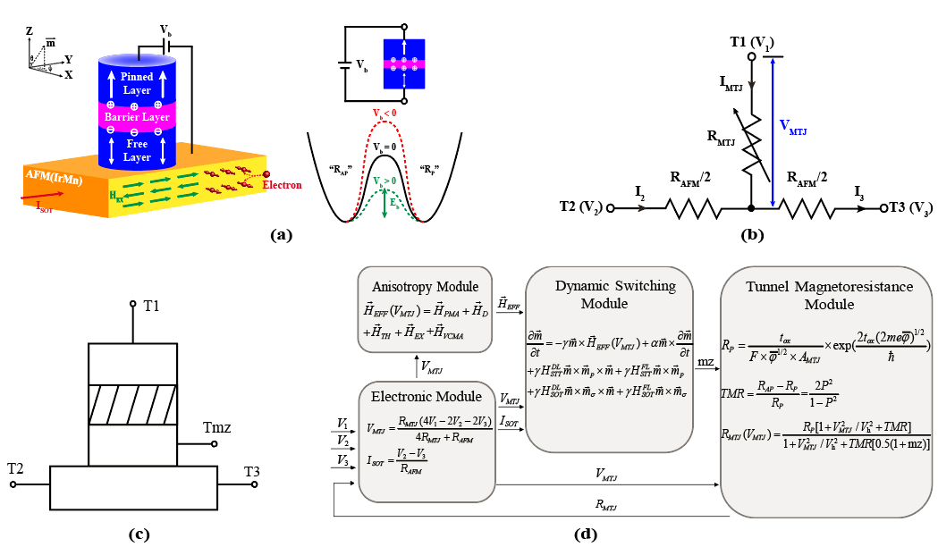

Introduction

This model file introduces a compact model of a voltage-gated spin-orbit torque magnetic tunnel junction (VGSOT-MTJ), where one MTJ with perpendicular magnetic anisotropy (PMA) is fabricated on an antiferromagnetic-metal (AFM) stripe. This model integrates the physical models for both the static and dynamic switching behavior. To exactly describe the magnetization switching of the VGSOT-MTJ, the following effects are taken into account in this model: (1) Voltage-Controlled Magnetic Anisotropy (VCMA) effect induced by the bias voltage across the MTJ; (2) damping- and field-like Spin-Orbit-Torque (SOT) effect induced by the charge current flowing through the AFM stripe; (3) damping- and field-like Spin Transfer Torque (STT) effect induced by the charge current flowing through the MTJ. Additionally, both the dependence of the TMR ratio on the bias voltage and the relationship between the MTJ resistance and the magnetization polar angle are also considered in this model. It provides an easy way to simulate the non-volatile memory and logic circuits based on the VGSOT-MTJ device.

By Kaili Zhang1,2,3, Deming Zhang1,2,3, Chengzhi Wang1,2,3, Lang Zeng1, You Wang1,2 and Weisheng Zhao1,2

1. School of Microelectronics, Beihang University, Beijing 100191, China
2. Hefei Innovation Research Institute, Beihang University, Hefei 230013, China
3. School of Electrical and Information Engineering, Beihang University, Beijing 100191, China

References

[1] Kaili Zhang, Deming Zhang, Chengzhi Wang, Lang Zeng, You Wang and Weisheng Zhao, “Compact Modeling and Analysis of Voltage-Gated Spin-Orbit Torque Magnetic Tunnel Junction”, IEEE Access, vol. 8, no. 1, pp. 2169-3536, Mar. 2020. DOI: 10.1109/access.2020.2980073